ASSIGNMENT SUBMISSION COVER SHEET
Student Id: cse24-116
Student names: NEELO MIMI PILANE
Student email: cse24-116@thuto.bac.ac.bw
Cohort: 2025
Assignment title: CSE202- OBJECT ORIENTED ANALYSIS & DESIGN WITH JAVA
Date of submission:
Programme of Study: COMPUTER SYSTEMS ENGINEERING
Year of Study: Year 2
Intellectual property statement. By checking the box below, I certify that this assignment is my own work and is free from plagiarism. I understand that the assignment may be checked for plagiarism by electronic or other means and may be transferred and stored in a database for the purposes of data-matching to help detect plagiarism. The assignment has not previously been submitted for assessment in any other unit or to any other institution. I have read and understood the Botswana Accountancy College plagiarism guidelines policy.
☐ Agree
Signature…………………………………….
Date………19/09/2025…………………………………..
Part A: System Documentation Instructions
Functional Requirements
User Verification (Login)- To access their accounts, customers must be able to log in safely. Authentication should only be available to registered customers.
Management of Accounts - Consumers are able to open savings, investment, and check accounts. It is possible for a customer to have more than one account.
Rules must be enforced by the system:
A savings account pays 0.05% interest each month and permits deposits but not withdrawals.
Investment accounts pay 5% monthly interest, accept deposits and withdrawals, and require a minimum initial deposit of BWP 500.
Usually used for salary payments, a cheque account requires proof of employment and permits deposits and withdrawals.
Usually used for salary payments, a check account requires proof of employment and permits deposits and withdrawals.
Deposit money - Funds can be deposited into any customer's account by both customers and bank tellers.
Withdraw money - Only investment and check accounts—not savings accounts—allow customers and bank tellers to take money out.
Non-Functional Requirements
Safety - The system must use authorization and authentication procedures to safeguard user data. The system should only be accessible by authorized users (customers, tellers).
Performance - Deposits and withdrawals should be processed by the system instantly. Interest must be calculated by the end of each month, or within an acceptable processing time.
Usability - The interface needs to be easy to use, accessible, and simple for both bank tellers and customers. The colors used should represent the current trends of technology e.g it is necessary to provide unambiguous error messages and confirmations.
Scalability - Multiple clients and accounts should be supported by the system without experiencing any performance problems.
Availability & Dependability - Customers should be able to access the system around-the-clock. All updates must be persistent, and transaction data should never be lost.
Sustainability - To facilitate updates, the system should be modular, separating the controller, GUI, and core logic.

Structural UML Modelling
1. USE CASE DIAGRAM
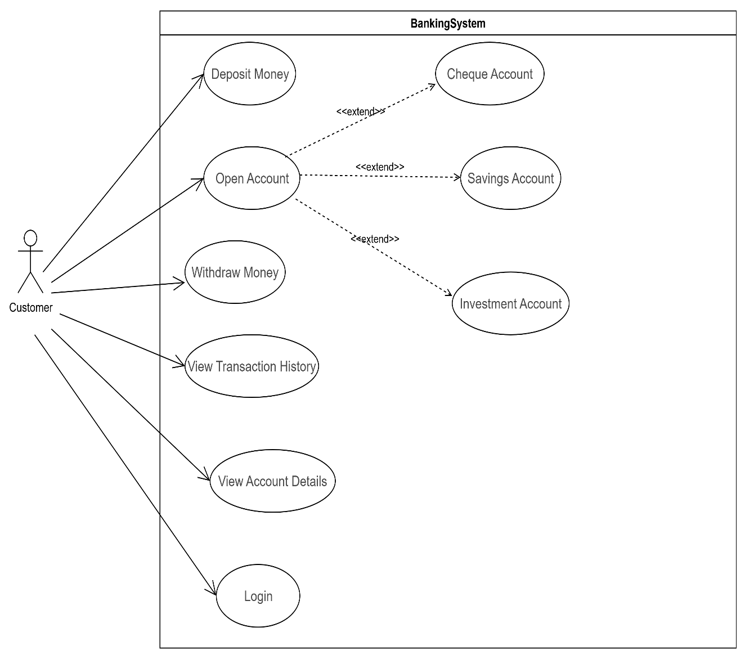
This use case diagram shows the banking system and what customers can do with it. The system allows customers to log in to access their accounts. Once logged in, customers can open different types of accounts including cheque accounts, savings accounts, and investment accounts.
Customers can deposit money into their accounts and withdraw money when needed. They can also view their account details to check their balance and personal information. The transaction history feature lets customers see all their past deposits and withdrawals.
The diagram shows all the main banking activities that customers can perform through the system to manage their money effectively.
CLASS DIAGRAM
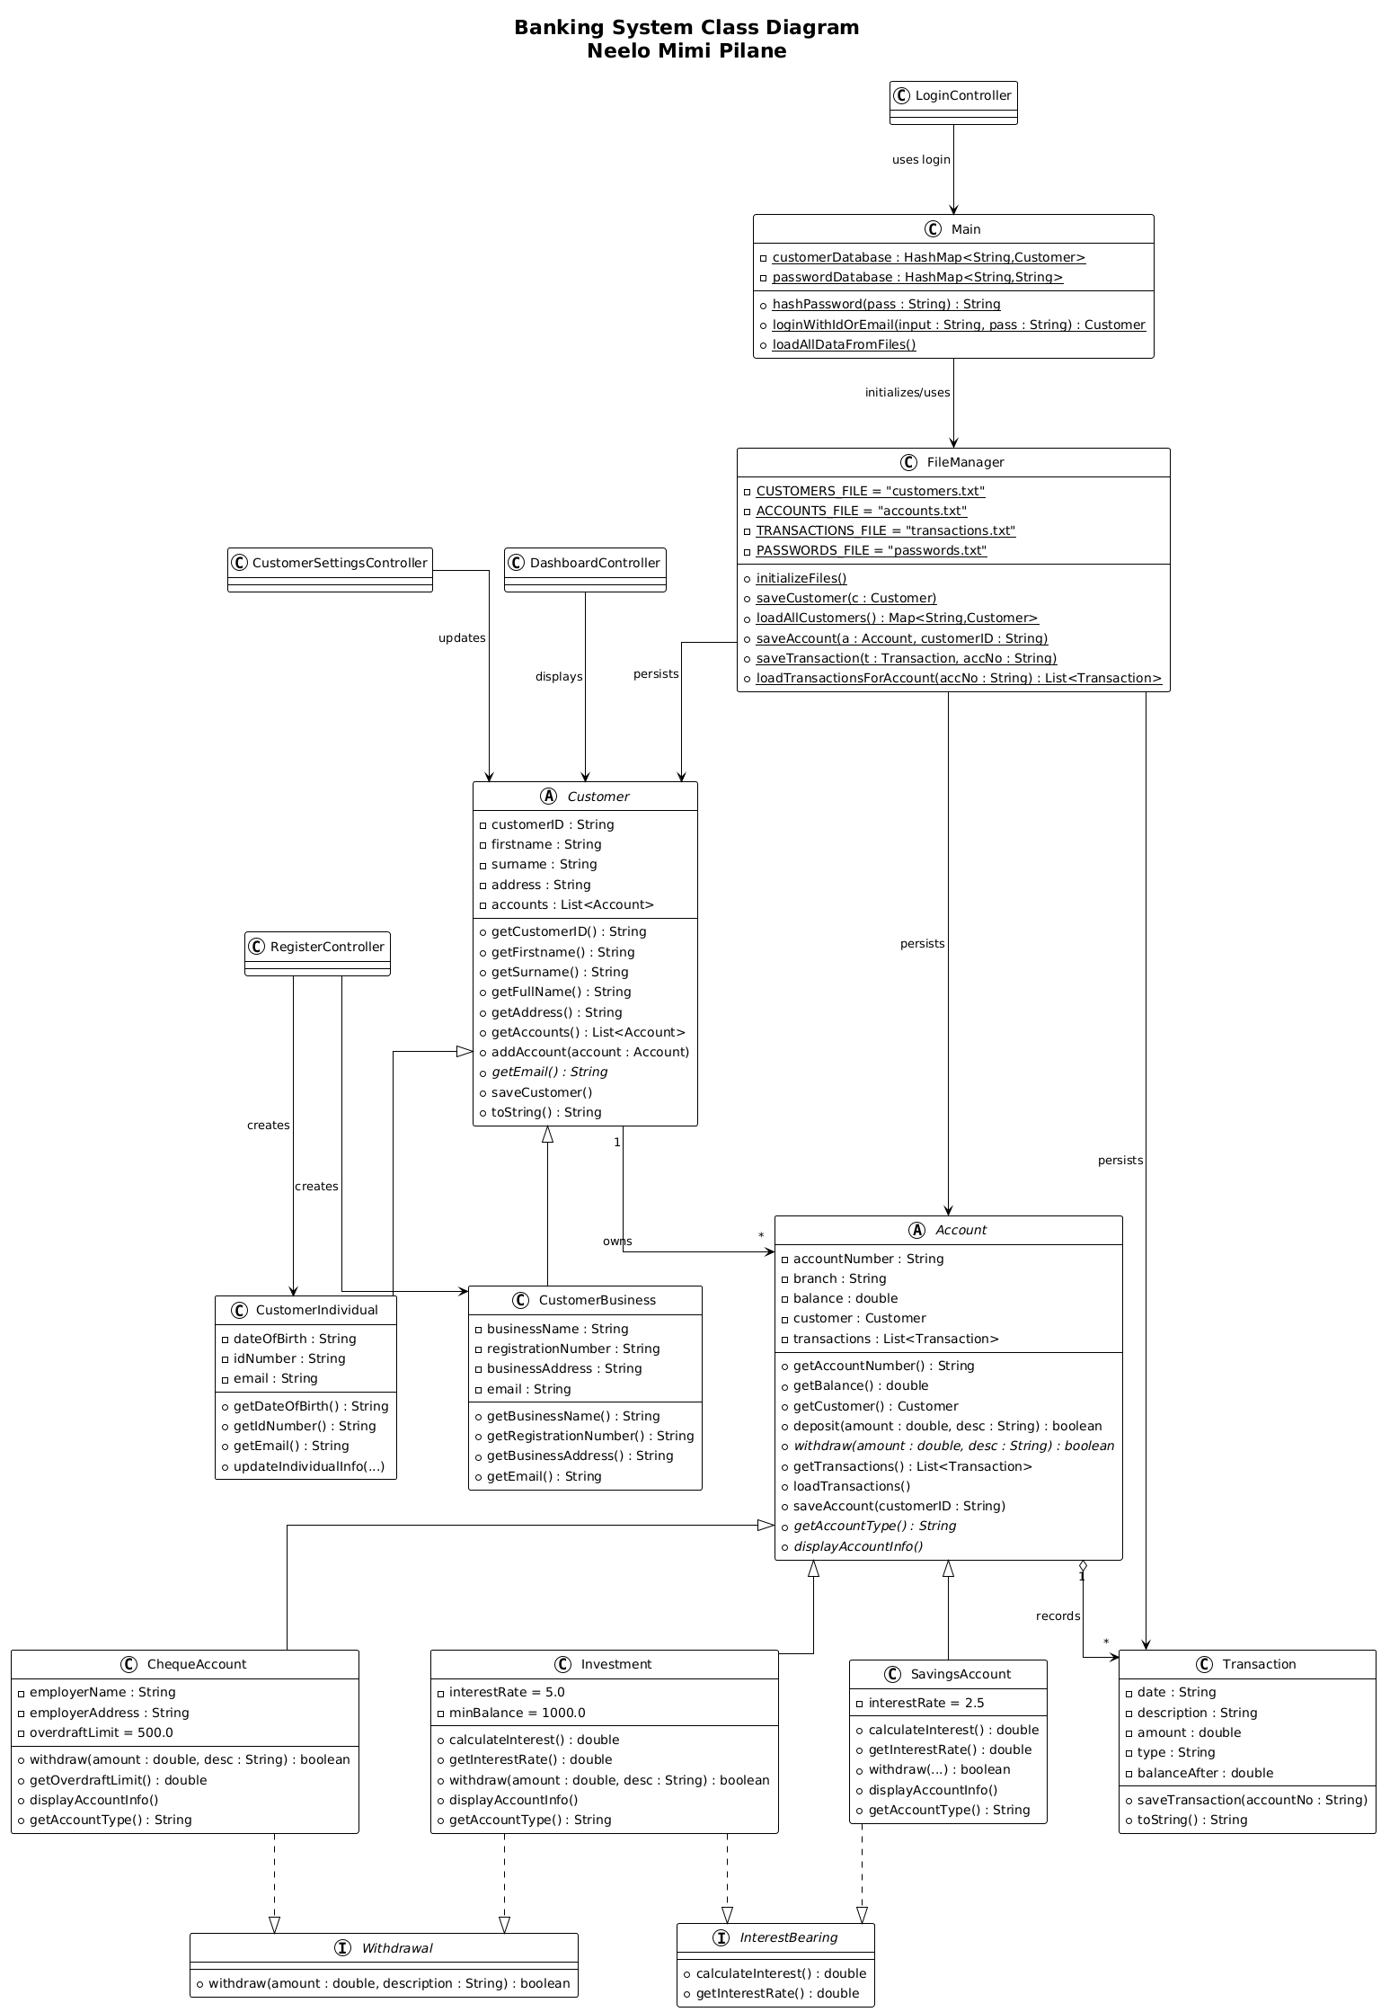

Banking System Class Diagram – Description
This class diagram shows the full structure of the JavaFX banking system. It follows good object-oriented rules like inheritance, polymorphism, encapsulation, and keeping things separate so the code is easy to understand and change.
- Main Classes (the model classes)
  - Customer (abstract class): Every customer has a customerID, first name, surname, address, and a list of their accounts.
  - CustomerIndividual and CustomerBusiness are the two real types of customers. Individual has date of birth and ID number; Business has company name and registration number. Both add their own extra details on top of the basic Customer.
  - Account (abstract class): Every account has an account number, branch, balance, and a list of transactions. It knows how to deposit money and save itself to file.
  - SavingsAccount, ChequeAccount, and Investment are the three real account types:
    - Savings and Investment earn interest (2.5% and 5% respectively) → they follow the InterestBearing interface.
    - Cheque and Investment let you take money out → they follow the Withdrawal interface.
    - Each type behaves differently when you withdraw or show details (this is polymorphism).
  - Transaction: Keeps the date, description, amount, type (deposit/withdrawal), and the balance after that transaction.
- File Handling & Program Start
  - FileManager: A helper class with static methods that reads and writes the four text files (customers.txt, accounts.txt, transactions.txt, passwords.txt).
  - Main: Starts the program, keeps two HashMaps in memory (one for customers, one for passwords), hashes passwords with SHA-256, and lets users log in with either their ID or email.
- Interfaces
  - InterestBearing: Forces the account to have calculateInterest() and getInterestRate().
  - Withdrawal: Forces the account to have a proper withdraw() method.
- Controllers (the buttons and screens)
  - LoginController, RegisterController, DashboardController, CustomerSettingsController: These JavaFX controllers take what the user clicks and talk to the classes above (Main, FileManager, Customer, Account).
- How everything is connected (UML symbols)
  - Inheritance → solid line with empty triangle
  - Interface → dashed line with empty triangle
  - Composition → black diamond (Account owns its transactions)
  - Aggregation → white diamond (Customer owns several accounts)
  - Numbers → 1 customer can have 0 or many accounts; 1 account has 0 or many transactions
  - Normal arrow → controllers use Main and FileManager
The whole system is easy to extend (we can add a new account type without touching old code), every class does one job only, and passwords are safely stored. It follows the Single Responsibility Principle and Open/Closed Principle properly.
Behavioural UML Modelling
SEQUENCE DIAGRAM (LOGIN PROCESS)
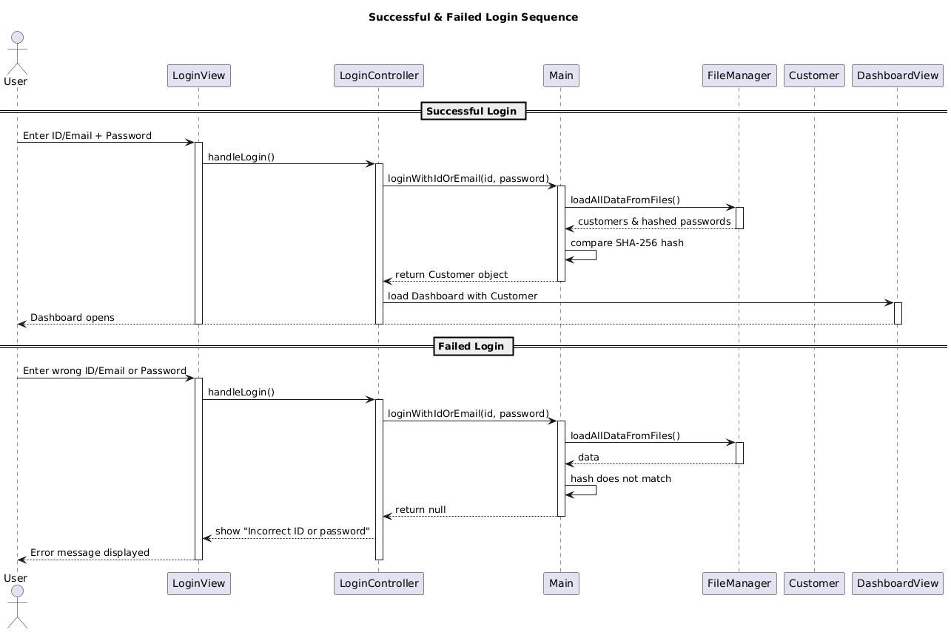
SEQUENCE DIAGRAM (DEPOSIT PROCESS)
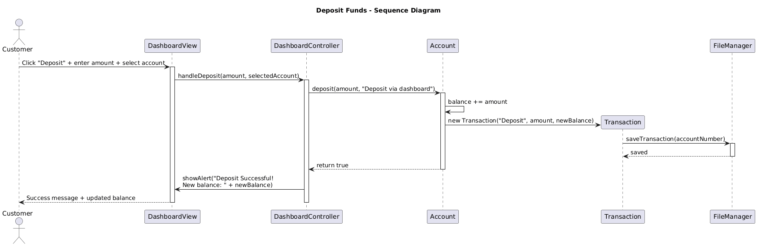
STATE DIAGRAM
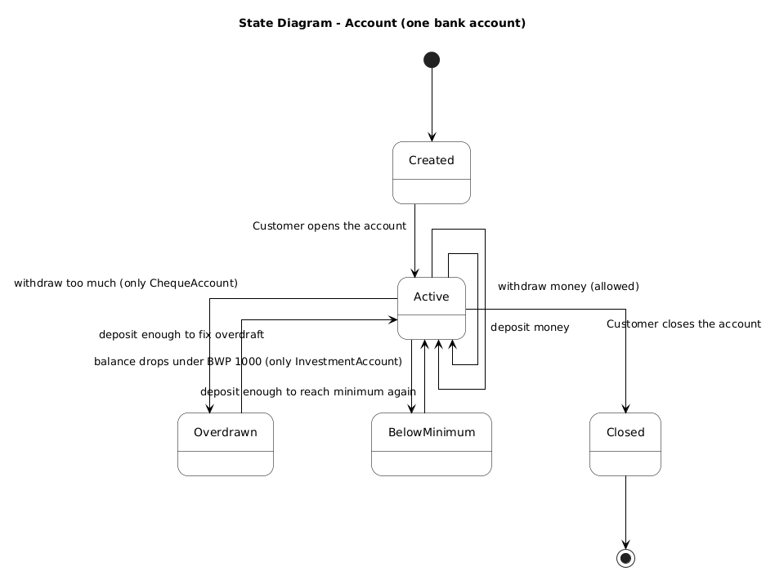
Interview Record
Project: Banking System OOAD Assignment
Student: Neelo Mimi Pilane
Date of Interview: 18/09/2025
Time: 0815/ 10:30
Mode: Microsoft Teams Breakout Room 1
Interviewee(s) : Mr Themba Moeng and Mr Kentsenao Baseki
Interviewer: Neelo Mimi Pilane

Purpose of Interview
The purpose of this interview was to gather detailed requirements and understand the processes of the banking system to support the creation of Use Case, Sequence, and State Diagrams.

Interview Questions & Responses
 | Question | Response / Notes
1 | Can you describe how customers log in to the banking system? | Customers enter their username and password. The system verifies credentials and grants access.
2 | What operations can a customer perform once logged in? | Deposit funds, withdraw funds, view account balance, view transaction history.
3 | How does the deposit process work? | Customer enters amount then system updates account balance then confirmation displayed.
4 | How does the withdrawal process work? | Customer requests amount then system checks balance then deducts amount then confirmation displayed.
5 | Can customers open new accounts? | Yes, through the system; staff assists with verification.
6 | Are there different types of accounts? | Yes. Savings, investment and cheque accounts.
7 | Is a customer allowed to have many accounts? | Yes. A customer can have many different types of accounts but not many accounts that are of the same type.

Observations & Notes
- Customers interact with the system primarily through the user interface or GUI.
- Controllers handle the logic between views and core data models.
- The interview provided clarity on edge cases and user roles.

Signature of Interviewer
Name: Neelo Mimi Pilane
Date: 18/09/2025

